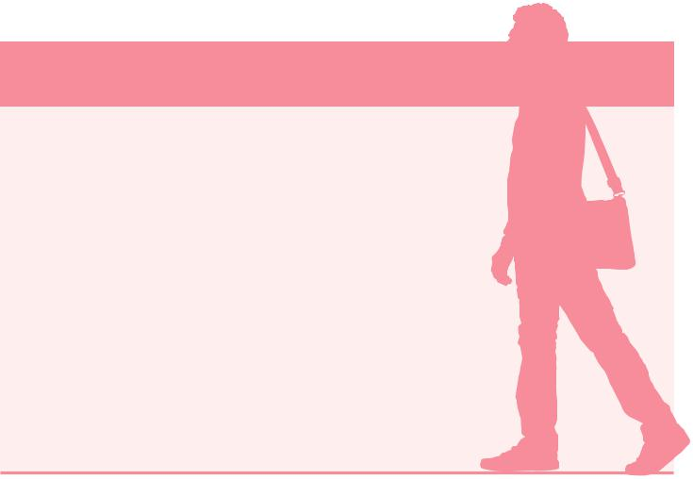
7. Changes of circumstances

Any beneficiary of the temporary protection claiming the ADA, must inform their competent regional OFII office of any changes to their personal and family circumstances (birth, persons joining them, separation, etc.) They must inform the OFII of any change in their financial resources and any new professional activities.

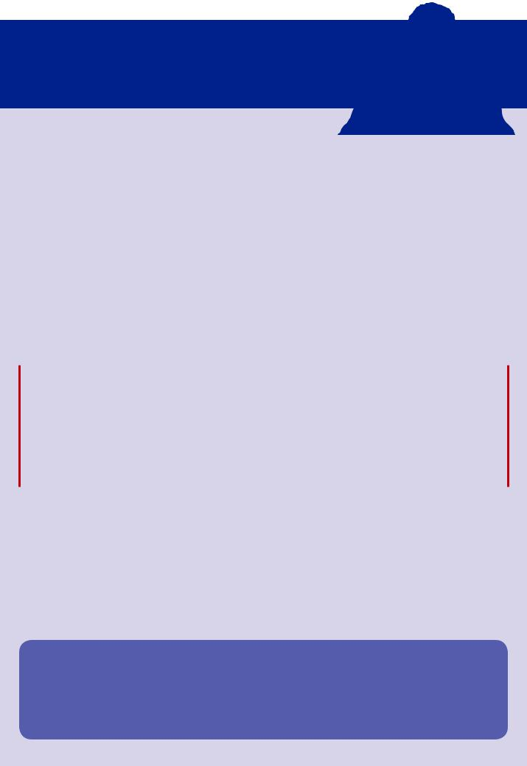

- Payment procedure

Each month, the ADA is paid on a personal payment card, which is given by the OFII to the beneficiary.

The first payment is made within 20 to 35 days. The recipient will receive a text message on their mobile phone informing them that the card has been loaded.

Warning! The beneficiary must only use their card after activation, in order to avoid any risk of blocking it.

Additional information can be found on the letter accompanying the card.

For any questions related to the use of this personal payment card, the recipient can contact 05 32 09 10 10.

For any further informations on the temporary protection, please visit the website of the ministry of the Interior: https://www.interieur.gouv.fr

For any further informations about the ADA, please visit website of the OFII : www.ofii.fr

Maquette : ASP / DirCom - Pao-création graphique - février 2016

A D A

ALLOWANCE FOR
RECIPIENTS OF THE TEMPORARY PROTECTION

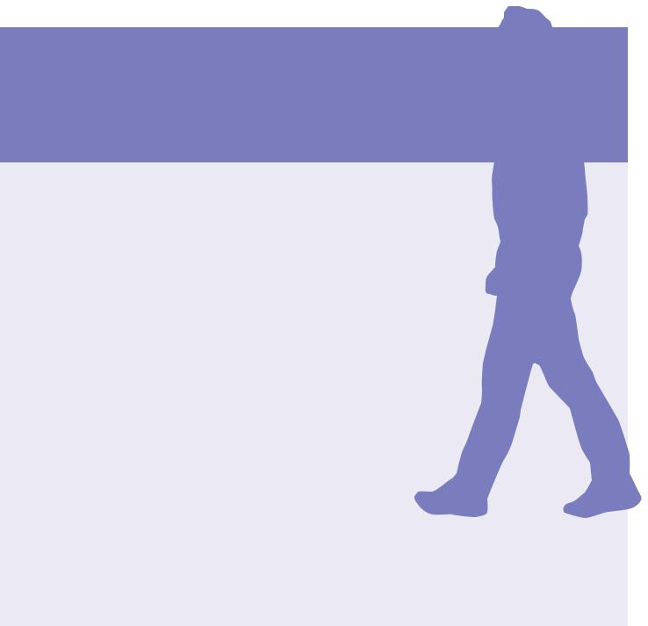

1. What is the temporary protection ?

Temporary protection is an exceptional measure authorized by decision of the Council of the European Union. It aims to protect people who are massively displaced from a third country and cannot return in safe and lasting conditions.

Recognition of temporary protected status results in the issuance, by the prefecture, of a temporary stay permit valid for six months, with the mention “beneficiary of temporary protection”. It is renewable as long as the protection lasts.

The temporary protected status gives access to a certain number of rights and in particular to the allowance for asylum seekers (ADA).

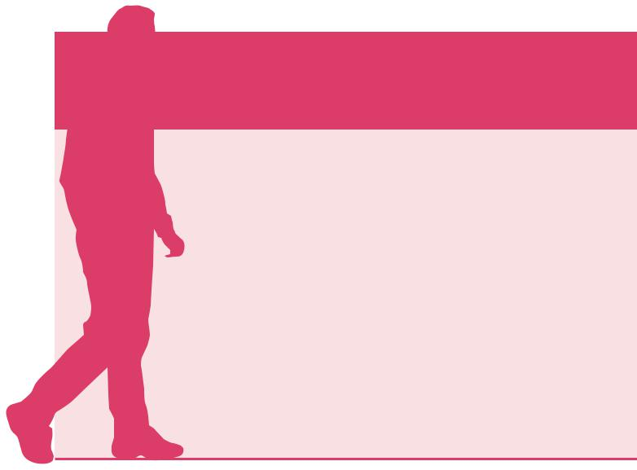

2. Where should an ADA application be made ?
The temporary protected person requests the ADA:

•after obtaining their temporary stay permit, from the OFII counter present at the prefecture;

•or exceptionally to the territorially competent OFII office of which it depends. The contact details of the territorial offices of the OFII are available at: https://www.ofii.fr/en/ou-nous-trouver/

3. Under which conditions can one benefit from the ADA ?

To benefit from the ADA, the temporary protected person must meet the following conditions:

• be in possession of a valid temporary stay permit bearing the mention “beneficiary of temporary protection”;

• be over 18 years of age;

• have monthly resources lower than the amount of Active Solidarity Income (RSA).

4. What is the amount of the ADA ?

The ADA is paid monthly based on a scale which takes into account :

- their own personal and family income ;
- the kind of accommodation they have;
- the number of adults and children who make up the family

ADA payments by family composition

Family composition | Daily total |  | Family composition | Daily total
1 person | 6,80 | € | 6 persons | 23,80 €
2 persons | 10,20 | € | 7 persons | 27,20 €
3 persons | 13,60 | € | 8 persons | 30,60 €
4 persons | 17,00 | € | 9 persons | 34,00 €
5 persons | 20,40 | € | 10 persons | 37,40 €

An additional daily allowance of 7.40 is paid to each adult.

- How long is the ADA paid for ?

The ADA is paid to the temporary protected person until:

• the expiry date of their stay permit, issued pursuant to article L.581-3 of the French Code of entry and residence;

• the end of Temporary Protection as decided by the Council of the EU;

• obtening another residence permit.

Warning ! To avoid the interruption of payments, it is imperative to present the renewal of the temporary residence permit to the OFII.

6. Documents to produce when filing the ADA application:
• the temporary stay permit (APS) with the mention "beneficiary of temporary protection", valid and issued by the prefecture;
• ID associated with the APS;
• any evidence attesting its resources and family composition.

